WestCon Community Action Groups | No M4 East
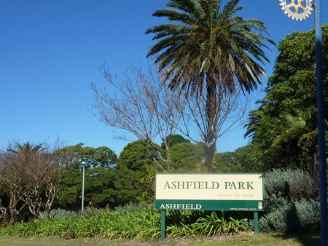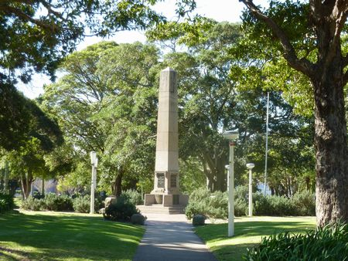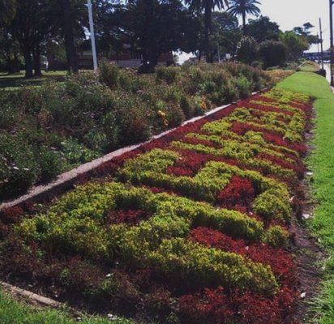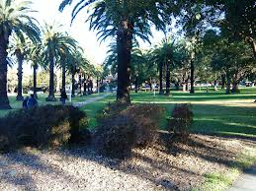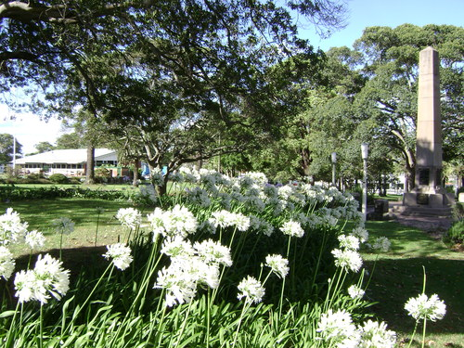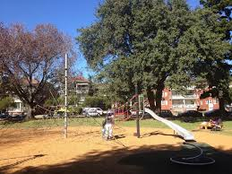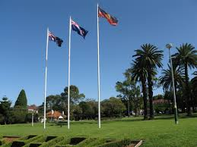
Your Lobbying List
If you want to make a difference to our suburbs and raise your concerns then you must lobby these influential people. Send them emails, letters, ring, fax, email – get involved, get active. Make contact regularly with them – daily, weekly, and remember these people have the power to change our lives forever!
Parts of Ashfield LGA are covered by three State Members-
Strathfield | Charles | Casuscelli | strathfield@parliament.nsw.gov.au
Balmain | Jamie | Parker | jamie.parker@parliament.nsw.gov.au
Canterbury | Linda | Burney | linda.burney@parliament.nsw.gov.au

NSW Ministers with Transport and Infrastructure Responsibilities
Premier | Barry | O'Farrell | www.premier.nsw.gov.au
Minister for Ports and Roads | Duncan | Gay | office@gay.minister.nsw.gov.au
Minister for Transport | Gladys | Berejiklian | office@berejiklian.minister.nsw.gov.au
Minister for Planning and Infrastructure | Brad | Hazard | office@hazzard.minister.nsw.gov.au

Our Federal Member of Parliament
Grayndler | Anthony | Albanese | A.Albanese.MP@aph.gov.au

Ashfield Council – Email addresses for Councillors

Lucille | McKenna (Mayor) | lucille.mckenna@bigpond.com
Caroline | Stott | cestott@hotmail.com
Alex | Lofts | the.lofts@bigpond.com
Ted | Cassidy | ecas@bigpond.net.au
Mark | Drury | mark_drury@bigpond.com
Morris | Mansour | mansour.morris@gmail.com
Julie | Passas | 0419 206 855
Adriano | Raiola | Adriano.raiola@hotmail.com
Max | Raiola | max@ashfieldliberals.com.au
Vittorias | Ricitti | vittorias.raciti@gmail.com
Jeanette | Wang | jeanettewang168@gmail.com
Monica | Wangman | wangmann@ihug.com.au

WestConnex
To get in contact with WestConnex Delivery Authority phone 1300 660 248
Go to their website – www.westconnex - “Have your say” page Email: info@westconnex.com.au

