WestConnex Part 2:
For Sale: Your Street, Your Community
Have a look at this map. If you live in any of these yellow coloured areas then you need to know that your local Council is currently trying to decide if they want to sign an agreement with Urbangrowth NSW’s WestConnex Revitalisation Project Team which will enable the State Government to change local planning controls and remove local governance that protects your street and your community from overdevelopment.
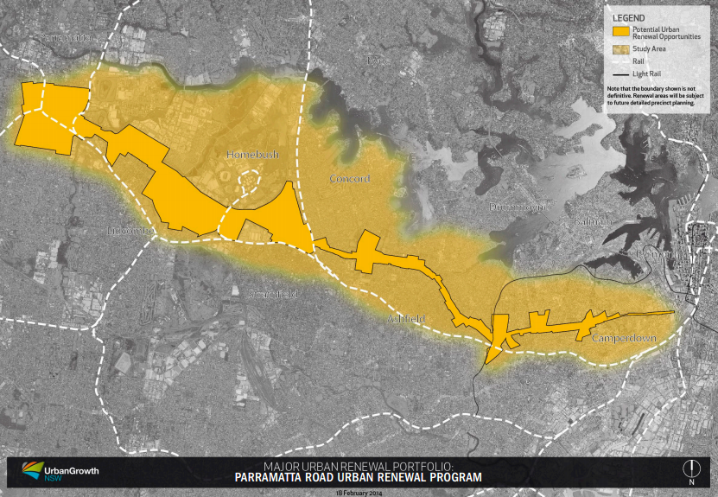
It is not too late to stop this from happening.
All 10 Councils: City of Sydney, Marrickville, Leichhardt, Ashfield, Burwood, Canada Bay, Strathfield, Auburn, Parramatta and Holroyd have been asked to sign an agreement called a Memorandums of Understanding or MOU. They are being asked to “amalgamate” into 3 super councils (called “precincts”- western Precinct, Central Precinct and Easter Precinct) for the purpose of this re-negotiation of governance and handing over to the State Government of planning controls for the Parramatta Road Corridor.
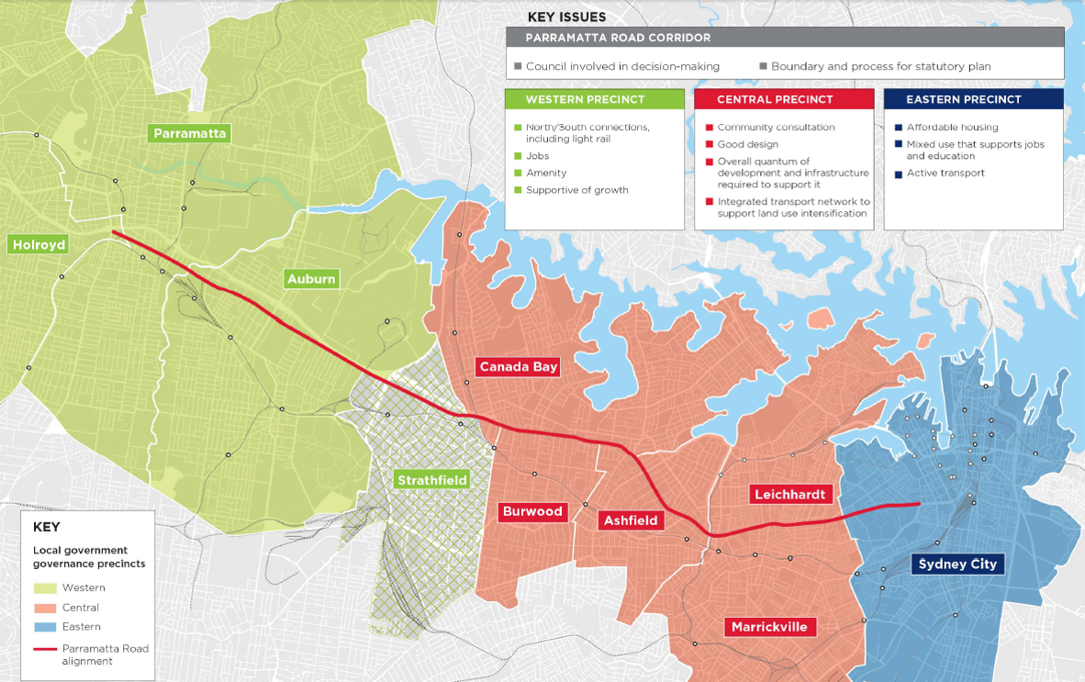
The MOU contains the following inducements to sign:
- Money - $200 million in infrastructure works distributed between the 10 councils to facilitate the high rise development. Also paying 5 council staff salaries – to be selected from the 10 councils to work in the WestConnex Revitalisation Project Team.

- Threats – if you don’t sign it then we may not keep you in the loop and tell you what we are going to do (this is rubbish as they are required by law to consult with all stakeholders including local councils and local communities)

- Collusion – the MOU will enable the Government to say that the Councils “worked with them” and wanted to give away their planning powers. The Draft MOU states: “councils will have a role in the statutory planning of the Precinct Planning and Delivery Phase of the project” however the only role identified in the MOU is in fact to give “advice” to the State Government authorities – further there is no requirement for the State Government to listen or to heed that “advice” , in fact they can completely ignore it while still stating that they “worked with local councils to develop new planning controls and governance arrangements”.

- Legitimacy to remove local governance and local planning controls. If local councils participate in this MOU it will provide legitimacy to what the State Government has planned to do all along which is remove local planning controls and local governance from parts of the Parramatta Road corridor.

- Developer-friendly Councillors and Mayors achieve high rise without the political consequences: Unfortunately some local Councillors and Mayors want high rise development, engaging in this agreement enables them to achieve this and then to blame it on State Government.

- Parramatta Road Urban Renewal Program – sounds like the project will entail improvements to the liveability of Parramatta Road. It won’t. This MOU is only about legitimising high rise development and the removal of local governance and local planning controls from Local Councils.
It is clear that if your local Councillors and your local Mayor are serious about stopping the State Government from overriding local planning controls then they should not be signing this MOU on behalf of their local communities.
What is the current status of the 10 Councils with regards to signing the MOU?
- City of Sydney: Currently no resolution to sign the MOU. Next meetings March 31st, April 7th 2014.
- Leichhardt: Currently no resolution to sign the MOU. Next Council meeting 25 March 2014.
- Marrickville: 4 March resolution to delegate to the General Manager to enter into the MOU (Councillors and the public will not have seen the MOU).
- Canada Bay: 18 March resolution to authorise the Mayor and General Manager to enter into the MOU (Councillors and the public will not have seen the MOU).
- Ashfield: Currently no resolution to sign the MOU. Next Council meeting 25 March 2014.
- Burwood: Currently no resolution to sign the MOU. Next Council meeting 31 March 2014.
- Strathfield: Currently no resolution to sign the MOU. Next Council meeting 1 April 2014.
- Auburn: Currently no resolution to sign the MOU. Next Council meeting 16 April 2014.
- Parramatta: Council has a resolution for the Mayor to negotiate the MOU but it needs to be returned to council for approval before signing. Next Council meetings 24 March, 14 April, 28 April 2014.
- Holroyd: Currently no resolution to sign the MOU. Next Council meeting 1 April, 15 April 2014.

Timeline:
Apparently the State Government wants all the MOUs signed before NSW Cabinet meets on April 16th to decide what their preferred concept plan will be. The MOU’s purpose is to “develop the detailed concept plan and amenity improvement plan for Parramatta Road”

In other words – the councils and the community don’t get to decide what the preferred concept plan is –NSW Cabinet makes the decision for us. This “preferred” concept plan then goes out to “consultation”, we believe in May and June 2014 and then becomes the final concept plan at which stage the councils start to roll it out through the MOU.

This preferred concept plan will come from one of four scenarios – all of which really only talk about intensification of development and higher densities, they are:

Scenario 1: more intensification of development right across the corridor with more housing in the east and more jobs in the west.

Scenario 2: intensification of development across the corridor with same levels of housing and employment development.

Scenario 3: Focused development on North and South and away from the corridor – remote to Parramatta Road and more housing development.

Scenario 4: Focused development around 4 strategic locations, mostly around transport nodes with higher densities in precincts and emphasis on housing over employment.

What can you do to stop this from happening?
2 things:

- Write, Email, Phone and ask your Councillors and Mayor not to sign the current MOU.

- Write, Email. Phone, Tweet, Facebook: Tell your local State MP, the Premier and Ministers to stop trying to change local governance and planning controls along the Parramatta Road corridor.

Example email to your local Councillors/Mayor:

Dear Councillor XXXXXXXX,

I am asking you to protect my street and my community by keeping governance and planning controls local and saying no to the WestConnex “Parramatta Road Renewal” MOU agreement.

The Parramatta Road Urban Renewal Program will develop and roll out a concept plan for the Parramatta Road corridor, chosen by Cabinet on 16th April. This will be a plan to bring high density development into large tracts of the west and the inner west along the Parramatta Road Corridor.

Signing this MOU could result in effectively selling my street and my community to developers. It gives no power to councils and communities and complete power to the State Government, UrbanGrowth NSW and Planning NSW.

I ask that Council only signs an MOU on Parramatta Road renewal if that MOU:

- Guarantees the retention of local governance and all local planning controls by Councils.

- Ensures that Local Government and the State Government work as equal partners and that no decision is made without the agreement of both parties.

- Guarantees there will be real community engagement using a quality Community Engagement Framework model with a two-way consultative model providing many opportunities for all community members and stakeholders to be meaningfully consulted.

- Does not require rezoning to higher density development.

- Guarantees that no home or business will be compulsorily acquired by the State or Local Governments.

- Makes a commitment to develop Parramatta Road into a vibrant and liveable area with excellent public and active transport, sustainable retail, cultural and commercial businesses, is aesthetically pleasing and has excellent integration into the rest of the local area.

If the State Government cannot commit to these principles in an MOU on Parramatta Road Renewal then it is not serious about respecting local governance and planning controls and the need to meaningfully consult with local communities. Indeed signing the current MOU is as good as signing away the rights of the community and the rights of council.

Yours sincerely,

XXXXXXX

